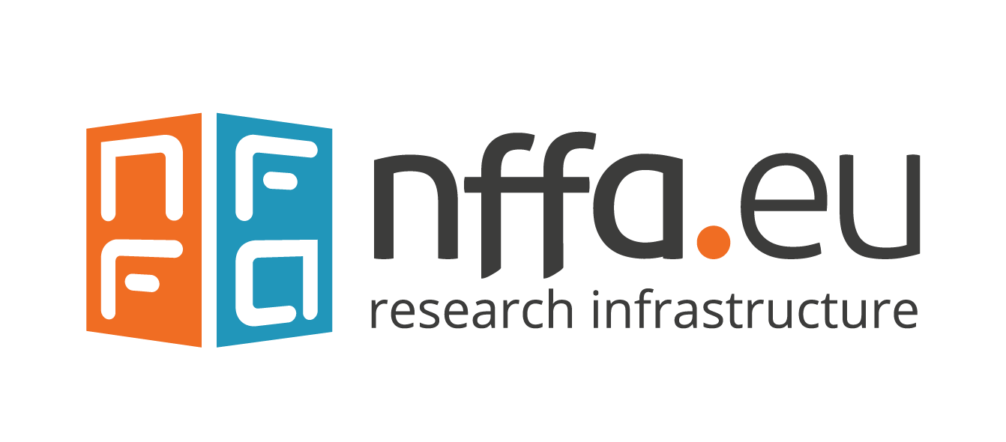
Call for Proposals: NFFA-Europe Dissemination Events
NFFA-Europe offers the opportunity to receive funding for the organization of dissemination events.
The dissemination events must be related to the project activities and organized by NFFA-Europe Pilot beneficiaries.
Up to four dissemination events may receive a financial contribution of up to €10,000 or 50% of the total costs, whichever is lower, during the NFFA-Europe Pilot lifetime.
Events must include session(s) organized by young users and students.
This initiative aims to promote deeper engagement with the NFFA-Europe Pilot project’s outcomes and facilitate broader participation. The proposals will therefore be evaluated also against the intended target audience, impact effectiveness and expected audience size.
To apply, please complete the following application form and send it, together with the CV(s) of the Scientific Organizer(s) and the Preliminary Program, to f.carsughi@fz-juelich.de by June 30, 2024.
For inquiries or assistance, please contact Flavio Carsughi: f.carsughi@fz-juelich.de

DISSEMINATION EVENT APPLICATION FORM
Applicant Information
Organization/Institution Name: | Click or tap here to enter text.
Scientific Organizer(s): | Click or tap here to enter text.
Contact Person: | Click or tap here to enter text.
Email Address: | Click or tap here to enter text.

Event Details
Event Title: | Click or tap here to enter text.
Proposed Date(s) of Event: | Click or tap here to enter text.
Proposed Location of Event: | Click or tap here to enter text.
Brief Description of the Event (approx. 250 words)
Click or tap here to enter text.
Expected Target Audience: | Click or tap here to enter text.
Expected Audience Size: | Click or tap here to enter text.

Budget
Total Estimated Cost of Event: | Click or tap here to enter text.
Amount Requested from NFFA-Europe Pilot: | Click or tap here to enter text.

Session Organization
Total Number of Sessions: | Click or tap here to enter text.
Title and Speaker(s) for each Session (even if preliminary)
Click or tap here to enter text.
Description of Session(s) to be Organized by Young Users and Students:
Click or tap here to enter text.

Impact Assessment
How do you expect the event to contribute to the dissemination of the NFFA-Europe Pilot project’s outcomes?
Click or tap here to enter text.
How do you plan to evaluate the effectiveness of the event in reaching its objectives?
Click or tap here to enter text.

Additional Information
Please provide any additional information relevant to your application.
Click or tap here to enter text.

Personal data will be processed according to NFFA-Europe privacy policy

